Complete Meal:
For 6- $85.99
For 7 to 10 - $139.99
For 11 to 15 - $214.99

Salad
Cranberry Sauce or
Garden Salad w/ romaine lettuce,
tomatoes, cucumbers, red onions,
and dressing of choice

turkey
Oven Roasted Whole Turkey w/ Gravy
Turkey Breast w/ Gravy $5.99 extra

sides (choose 3)
Sweet Potato Casserole
Green Bean Casserole
Mashed Potatoes
Wild Rice Stuffing
Brown Sugar Glazed Carrots

Rolls
Old Fashioned Yeast Rolls
Whipped Honey Butter

DESSERT (INDIVIDUALLY PRICED)
Pecan Pie - $16.99 each
Pumpkin Pie - $14.99 each
Fruit Cobbler of Choice - $14.99 each

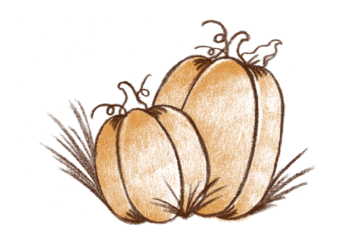

A LA CART:

Salad
½ Pan - $10.99
Full Pan- $18.99
Cranberry Sauce or
Garden Salad w/ romaine lettuce,
tomatoes, cucumbers, red onions,
and dressing of choice

turkey
Oven Roasted Whole Turkey w/ Gravy - $27.99 (12lbs)
Turkey Breast w/ Gravy $35.99 (6-8 lbs)

sides (choose 3)
½ Pan - $11.99
Full Pan- $19.99
Sweet Potato Casserole
Green Bean Casserole
Mashed Potatoes
Wild Rice Stuffing
Brown Sugar Glazed Carrots

Rolls
Old Fashioned Yeast Roll - $5.59 a dozen
Whipped Honey Butter -$5.59 for 10 oz.

