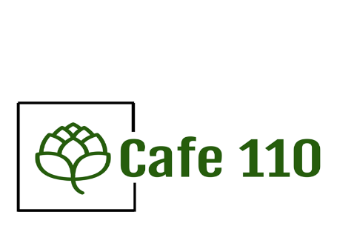
110 N Robinson Ave
Oklahoma City, OK
73102
405-724-7195
www.cafe110okc.com

CATERING MENU - DINNER
The cost included serve as note, and disposable Tableware.
There will be delivery fee on $20 for deliveries within a 20 mi radius of our location, $40 delivery fee for greater than 20 mi

DINNER OPTIONS
Select 1 protein Main, 2 Side
$16.50 Self Service Buffet- Includes deliver, set-up, 1 server to maintain buffet, and clean-up
$18.50 Full-Service Buffet- Includes deliver, set-up, 2 - 3 servers to serve guest, and clean-up
AMERICAN CUSINE: Served with salad and homemade yeast rolls
Protein – select 1
Pulled Pork
Grilled Pork Chops
Beef Brisket
Beef Tips
Rosemary Chicken Breast
Fried Chicken
Herb Roasted Chicken
Sides- select 2
Baked Beans
Green Beans
Spicy Brussel Sprouts
Steamed Broccoli and Carrots
Garlic Roast Potatoes
Mashed Potatoes
Macaroni Salad
Cole Slaw
Corn on the Cob (in butter)
MEXICAN CUSINE: Served with Fresh Tortillas (corn & flour) & chips and salsa
Protein – select 1
Fajita Seasoned Chicken
Fire Grilled Carne Asada
Green Chili Pork
Braised Shredded Pork
Ground Taco Beef
Sides- select 2
Pinto Beans
Black Beans
Mexican Rice
Guacamole
Cheese Sauce
ITALIAN CUSINE: Served with side salad and garlic rolls
Protein – select 1
Stuffed Manicotti with red sauce
Rosemary Chicken
Lasagna (beef
Sides- select 2:
Spaghetti
Fettuccine
Green beans
Sautéed Mushrooms
Tomato Basil Soup

